**PRACTICAL-3**

**AIM:**

Perform a Vulnerability Scan on a system within the Local Area Network and Submit the report

**THEORY:**

**NESSUS ESSENTIALS:**

* Nessus Essentials is a free vulnerability assessment solution for up to 16 IPs that provides an entry point into the Tenable ecosystem.
* Backed by market leading functionality from Nessus Professional, Nessus Essentials gives you the accuracy and speed you need to discover, prioritize and remediate vulnerabilities.

**IMPLEMENTATION:**

* Firstly, Nessus Essential is not pre-installed. Hence, we need to download it.

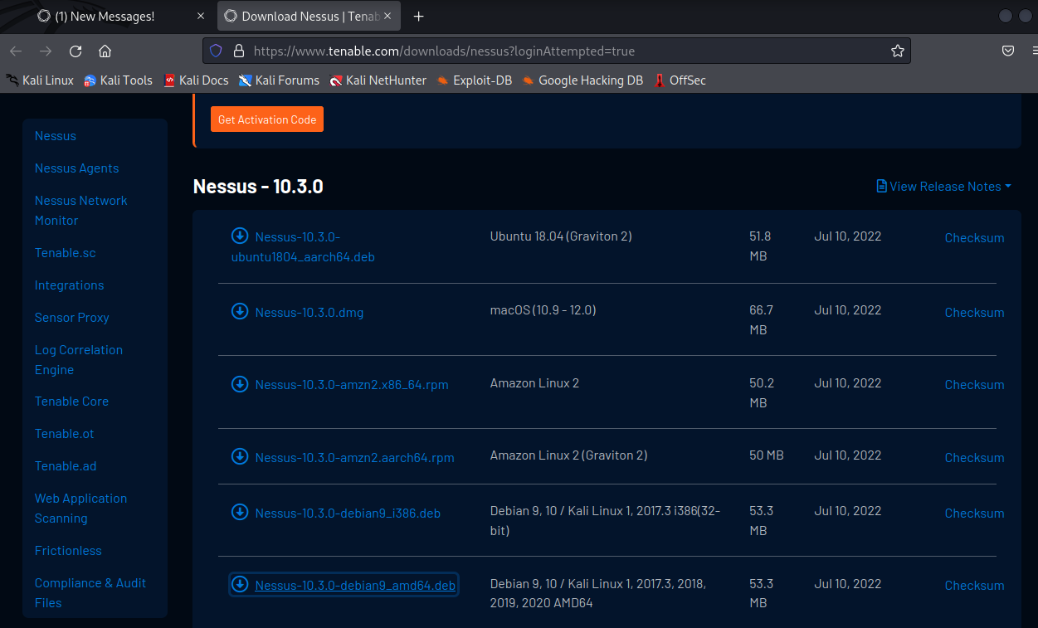

* Accept the Agreement.

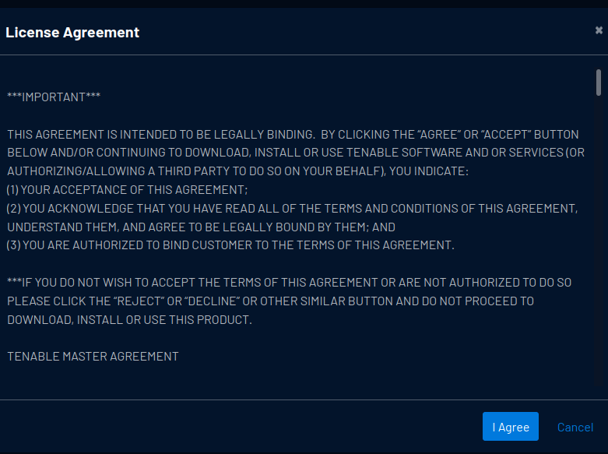

* Now, unpack the package

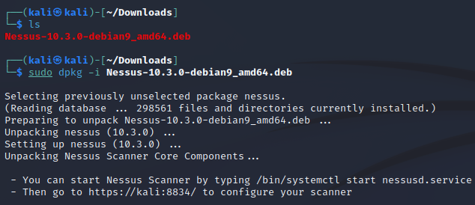

* Now, enter the following commands.

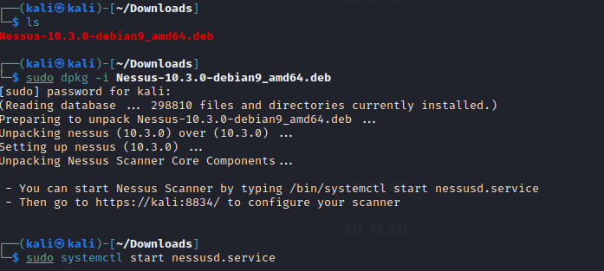

* Check the status.

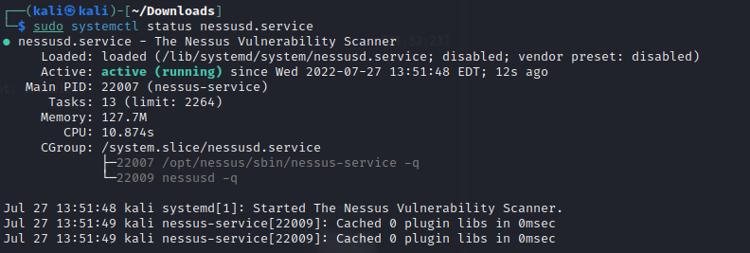

* Go to the link provided and proceed further. (<https://kali:8834>)
* The installation page will arrive

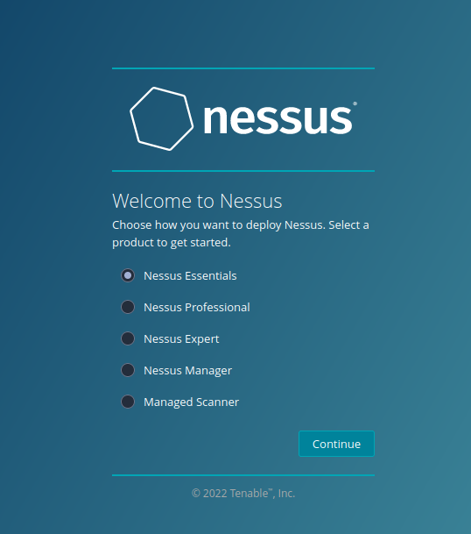

* Apply the activation code.

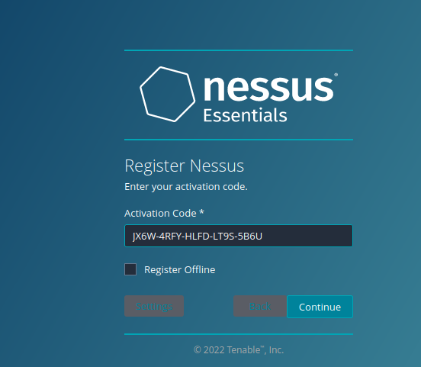

* After providing the user_name and password, download process will begin.

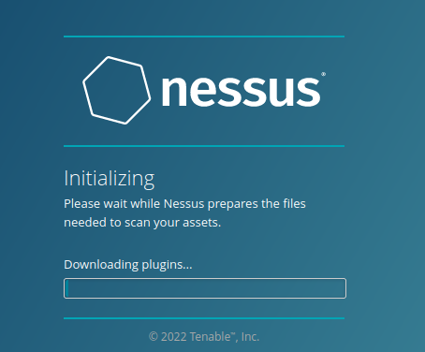

* Once, all plugins are installed, it will prompt you to enter the details of hosts that you want to check for.
* After that, it will start the scanning.

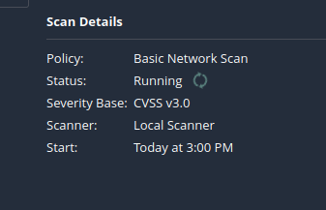

* Once completed, following information will be shown.

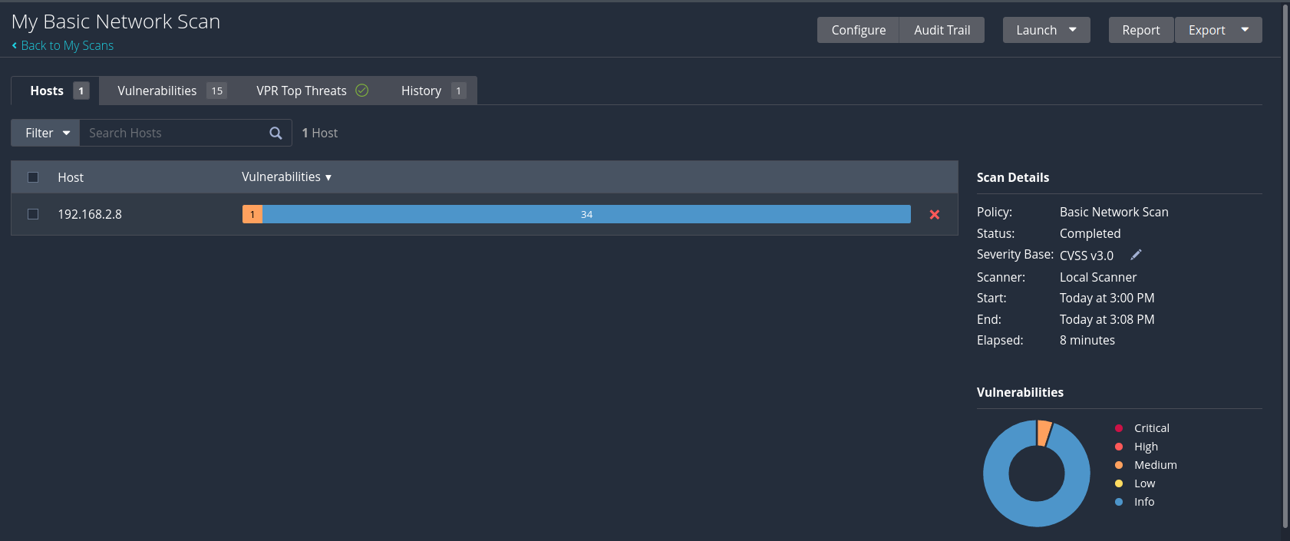

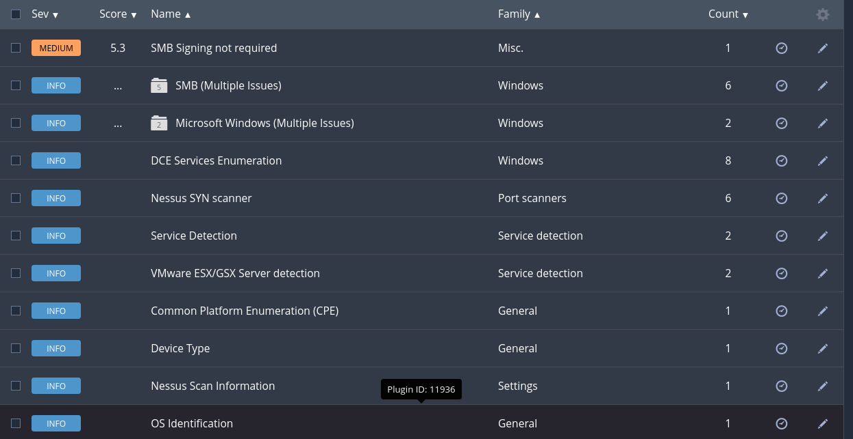

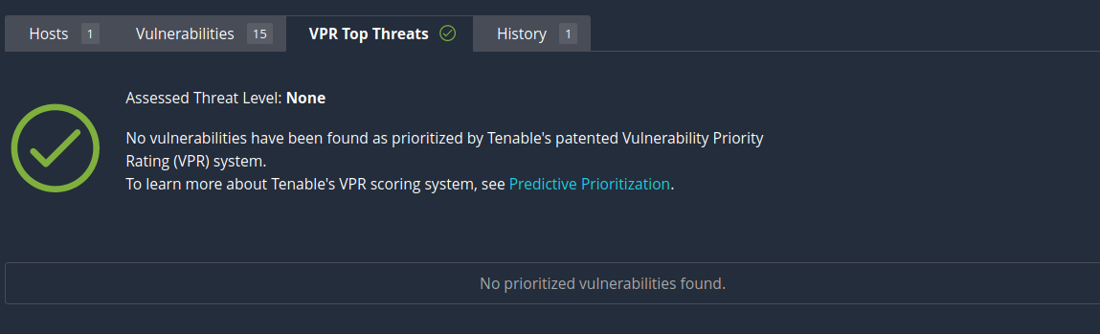

**CONCLUSION:**

* By performing the above practical, I learnt how to scan for vulnerability using Nessus essentials software.